4.4 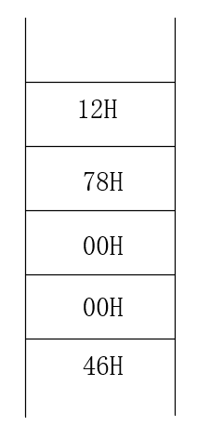

4.7

FLENGTH为 0010H，它表示从变量FNAME到变量COUNT之间的字节单元数。

PLENGTH为0016H,表示整个数据段的字节单元数

4.8

AX: 2345H

BX: 0E02H

CX: 2010H

SI: 0001H

DI: 2010H

4.10

DA1 DB ‘BADCFE’

DA2 DB 34H,12H,78H,56H

4.11

(1) AX: 0503H

(2) BL: 7BH

(3) BH: 05H

(4) CX: 01C8H

(5) DL: 00H

(6) DH: 0C8H

4.13

AX: 0028H

BX: 0008H

CL中’P‘的ASCII码

4.14

.386

.model flat, stdcall

.stack 4096

ExitProcess PROTO, dwExitCode:DWORD

INCLUDE Irvine32.inc

INCLUDELIB Irvine32.lib

.data

buffer BYTE 21 DUP (0)

byteCount DWORD ?

.code

main PROC

XOR ESI, ESI

MOV EDX, OFFSET buffer

MOV ECX, SIZEOF buffer

call ReadString

MOV byteCount, eax

STAR1: MOV BL, BYTE PTR [EDX+ESI]

CMP BL, 0DH

JZ END1

CMP BL,'a'

JB NEXT

CMP BL,'z'

JA NEXT

SUB BL, 20H;

NEXT: MOV BYTE PTR [EDX+ESI], BL

INC ESI

JMP STAR1

END1: MOV BYTE PTR [EDX+ESI], BL

call WriteString

INVOKE ExitProcess, 0

main ENDP

END main